ANSWER THE FOLLING QUESTIONS USING THIS LINK |
https://www.photographymad.com/pages/view/10-top-photography-composition-rules
- What is the Rule of Thirds?

- Download 3 images demonstrating the rule of thirds, resize and put them in the boxes.
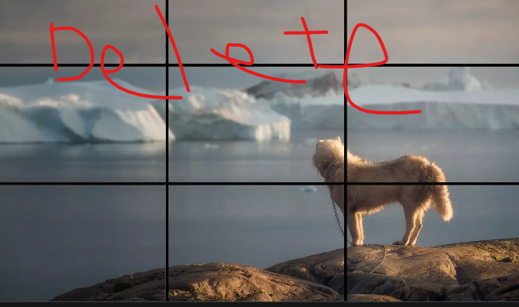

- What is the concept of balance?

- Download 2 images demonstrating balance, resize and put them in the boxes.
- How do Leading Lines help a picture/video?

- Download 2 images demonstrating leading line and put them in the boxes.

- How can Symmetry and Patterns enhance an image/video?

- Download 2 images demonstrating symmetry and patterns, resize and put them in the boxes.
- How can viewpoint affect the overall shot?

- Download 2 images demonstrating GOOD AND BAD viewpoint, resize and put them in the boxes.
- Why should one pay attention to the background of a photo/ video?

- What is framing?

- Download 2 images demonstrating framing, resize and put them in the boxes.
- (Do a search) What is the Golden Spiral in terms of photography/videography?

- Download 3 images that demonstrate the golden spiral.
